**Markel Online Product Guide**

**Table of Contents :**

1. Overview……………………………………………………………………………………………………………………………….
2. Lines of Business…………………………………………………………………………………………………………………...
3. General Liability………………………………………………………………………………………………………...
4. Property…………………………………………………………………………………………………………………….
5. Excess Liability……………………………………………………………………………………………………………
6. Inland Marine…………………………………………………………………………………………………………….
7. Liquor Liability……………………………………………………………………………………………………………
8. OCP……………………………………………………………………………………………………………………………
9. Special Event……………………………………………………………………………………………………………..
10. Users : Internal v External
11. Class Guide
12. QQ Transaction Stages………………………………………………………………………………………………………….
13. Step 1(Account Info)……………………………………………………………………………………………………….
14. Step 2(Coverages)……………………………………………………………………………………………………………
15. Step 3(Rates & Premiums)………………………………………………………………………………………………
16. Step 4(Review & Quote)…………………………………………………………………………………………………
17. Step 5(Review & Bind)……………………………………………………………………………………………………
18. Step 6(Review & Issue)……………………………………………………………………………………………………
19. Creating Transactions with different Lines of Business…………………………………………………………
20. Workflows……………………………………………………………………………………………………………………………
21. Admin Tool Integration…………………………………………………………………………………………………………
22. Useful links……………………………………………………………………………………………………………………………

**Markel Online Overview**

Markel Online is a secure, online portal which provides class information and underwriting resources to internal and external users.  Originally it was created by merging two existing portals created by Essex and Markel Southwest.  Its initially function was to provide a method for producers and underwriters to digitally access class information, which was historically found in paper manuals.

Today, Markel Online has been expanded to provide multiple tools and resources.  Users can view information on classes, product lines, and marketing materials.  Underwriting tools are available regarding underwriting guidelines, issuance, and property valuations.   A form library is available for reference, which includes coverage forms, declarations, endorsements, and notices.  Markel Online also provides reports on premium, policy expirations, and losses.   The Quick Quote tool allows producers to quote and bind policies for multiple product lines.

The users of Markel Online can be divided into two main groups, external users and internal users.  External users represent the majority of users.  These consist of wholesale producers that have been granted binding authority by Markel to write business on its behalf.  These producers may write business in any number of states and work with multiple carriers.  Internal users are comprised of Markel underwriters, assistants, and technicians.

**Lines of Business**

**a. General Liability**

Public liability or General Liability is part of the law of tort which focuses on civil wrongs. An applicant (the injured party) usually sues the respondent (the owner or occupier) under common law based on negligence and/or damages. Claims are usually successful when it can be shown that the owner/occupier was responsible for an injury, therefore they breached their duty of care.

The duty of care is very complex, but in basic terms it is the standard by which one would expect to be treated whilst one is in the care of another.

Once a breach of duty of care has been established, an action brought in a common law court would most likely be successful. Based on the injuries and the losses of the applicant the court would award a financial compensation package.

**b. Property**

Property insurance provides protection against most risks to property, such as fire, theft and some weather damage. This includes specialized forms of insurance such as fire insurance, flood insurance, earthquake insurance, home insurance, or boiler insurance. Property is insured in two main ways—open perils and named perils.

Open perils cover all the causes of loss not specifically excluded in the policy. Common exclusions on open peril policies include damage resulting from earthquakes, floods, nuclear incidents, acts of terrorism, and war. Named perils require the actual cause of loss to be listed in the policy for insurance to be provided. The more common named perils include such damage-causing events as fire, lightning, explosion, and theft.

**c. Excess Liability**

A policy issued to provide limits in excess of an underlying liability policy. The underlying liability policy can be, and often is, an umbrella liability policy.

An excess liability policy is no broader than the underlying liability policy; its sole purpose is to provide additional limits of insurance.

**d. Inland Marine**

Inland marine insurance in the United States indemnifies loss to movable or specialized types of property, historically developing as an outgrowth of ocean marine insurance. This category of insurance includes property coverage for construction equipment, medical diagnostic equipment, fine arts, solar panels and wind turbines, cameras and movie equipment, musical instruments, and a wide variety of other types of property.

The inland marine insurance definition has evolved over time to cover a wide range of property and materials:

* Property in transit
* Property in the custody of a Bailee
* Property deemed to be an instrumentality of transportation or communication, such as bridges and radio towers
* Mobile medical equipment
* Contractors equipment

**e. Liquor Liability**

Any establishment that sells, serves, or assists in the purchase or use of liquor (i.e. dram shop) opens its doors for a liability claim as a consequence of someone getting drunk to the extent that injuries or property damages are the result. This includes restaurants, bars, nightclubs, and taverns. While it’s logical that the inebriated person should be the one to pay, in reality the business that served the alcohol could be liable for injuries, damages, or both that occurred as a result of actions, behaviors, or conduct of a patron who drank too much.

**f. OCP (Owners and contractors protective)**

A stand-alone policy that covers the named insured's liability for bodily injury (BI) and property damage (PD) caused, in whole or in part, by an independent contractor's work for the insured. The contractor purchases the policy to provide coverage for vicarious liability the client (project owner) incurs as a result of the contractor's acts or omissions on the project. The OCP policy also responds to liability arising out of the insured's own acts or omissions in connection with its general supervision of the contractor's operations.

**g.** **SE (Special Event)**

Special Event Liability Insurance (also referred to as CGL, Commercial General Liability or Spectator Liability) is an insurance policy designed to provide broad protection for situations in which an event holder or concessionaire must defend itself against lawsuits or pay damages for bodily injury or property damage to third parties. Host liquor liability is included if there is no transfer of money for alcohol. This policy also gives protection to the venue and or sponsors of the event by adding them to the policy as an additional insured. Examples, such as a slip and fall or damaged floors are covered by this type of policy.

**Users : Internal vs External**

The users of Markel Online can be divided into two main groups, external users and internal users.  External users represent the majority of users.  These consist of wholesale producers that have been granted binding authority by Markel to write business on its behalf.  These producers may write business in any number of states and work with multiple carriers.  Internal users are comprised of Markel underwriters, assistants, and technicians.

**Internal Users**

 Internal Markel users are granted access to Markel Online through their employee account setup.  When accessing the Markel Online site, a single sign on process is used, removing the need to enter a user name and password.  They are automatically logged in, with no default agency.  **Internal users are able to access all functionality within Markel Online**.

**External Users**

External users require an account in the AMS system in order to access Markel Online.  To have an account created, the user will send an email request to RA MKL Client Service (ClientService@markelcorp.com), contact a Regional Marketing Representative, or contact the Service Desk.  The Marketing Representative will create an account in the AMS system based on the request.  Once created, the user will receive an automated email with their user name and password.

**Class Guide**

It gives you information regarding the class and it signifies the details such as the Authority, Rates and Premiums for the class and different Guidelines applicable to the class. Please find the snapshot on the following page.



**Home Page**

1.       User Account Information

2.       Site Search

3.       Logo

4.       Navigation Menu

5.       Announcements

6.       Class Search

7.       Outstanding Referrals

8.     Transaction Log

9.     Links

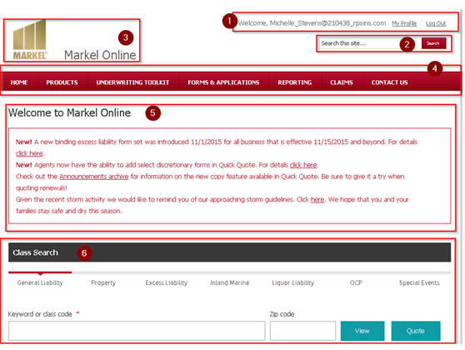

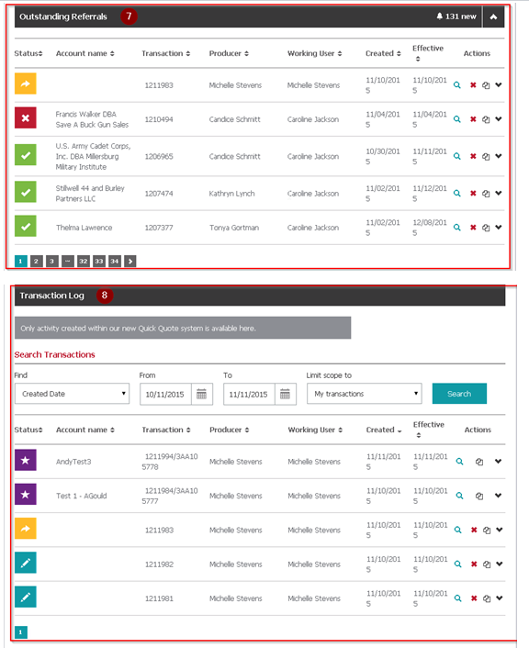



**Quick Quote Transaction Stages**

The user submits a quick quote by following the steps as below :

**Submit a Quick Quote:-**

* Click on the LOB name under class search tab to generate Quote for that specific LOB.
* Once LOB selected, Keyword or Class code field will enable user to select/enter its associated Class codes/coverage for which user needs to generate the Quote.
* After that clicking on ‘Quote’ button will navigate user to Step-1 where the actual quote generation process starts which is divided into 6 steps. Below are the step wise details along with screen-shots.

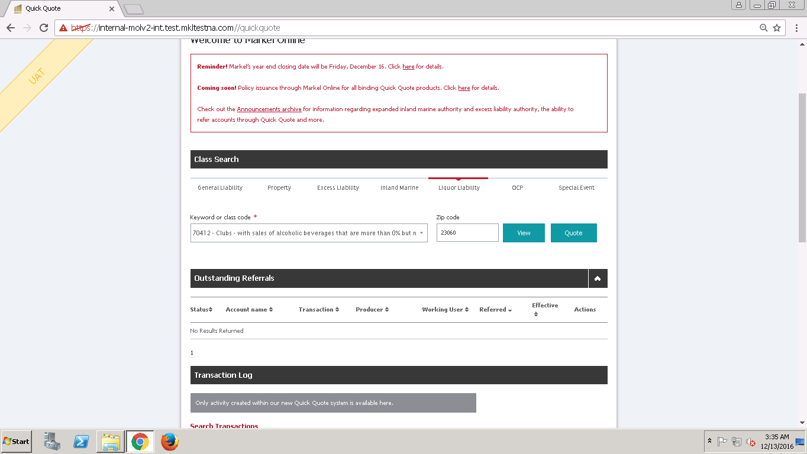

**Step 1(Account Info)** :- Step-1 form collects the basic information of Producer, his agency and End customer details such as Name, Address etc. Each step is having Save & Continue buttons which enables user to complete the current step form and Save or proceed further with the next step.

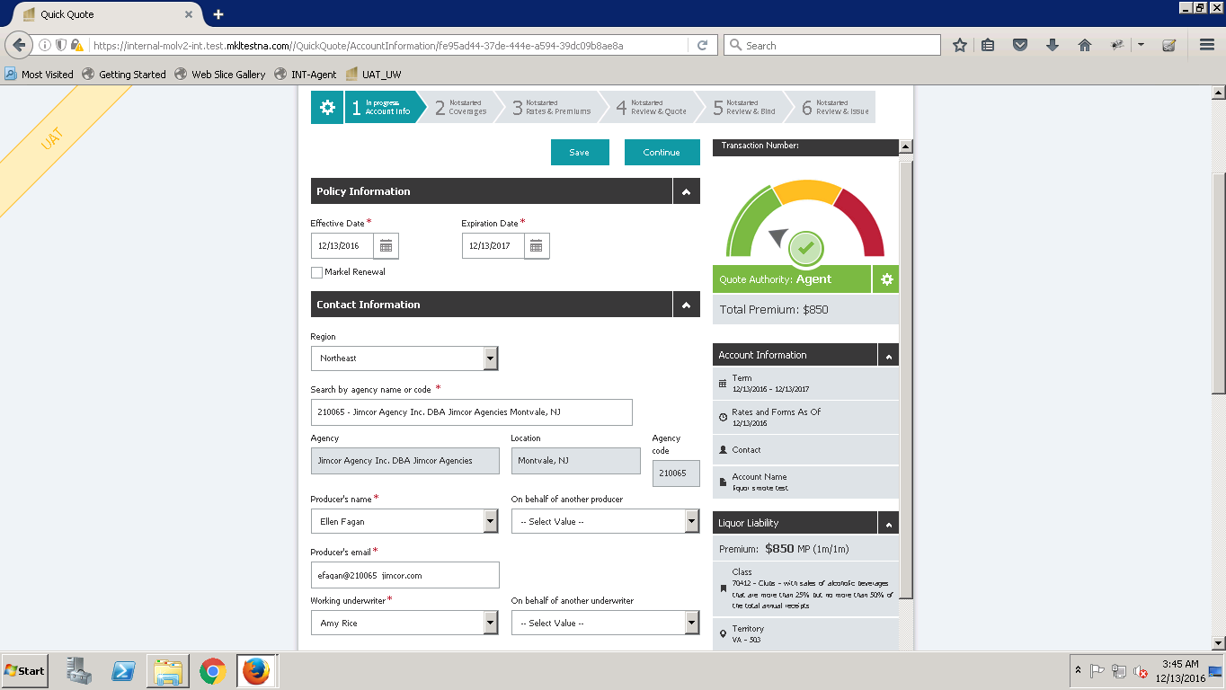

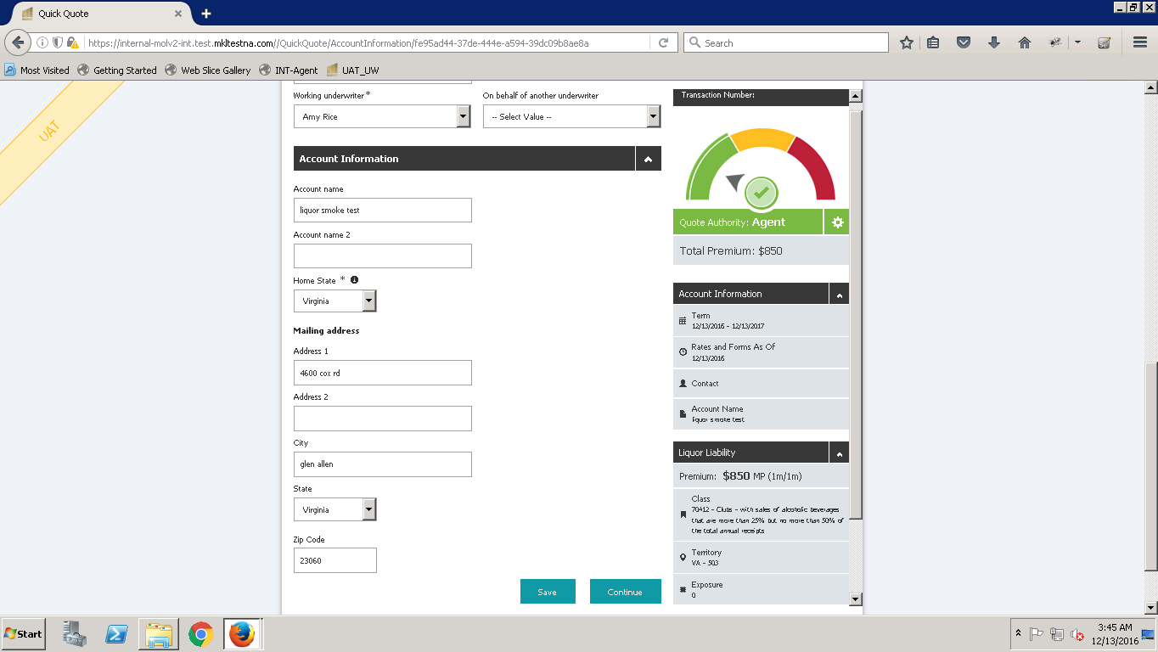

**Step 2(Coverage):-** Step-2 is a most important form amongst all steps as it allows agent/underwriter to select the coverages/optional coverages along with the required/applicable forms. There is dashboard on the Right side of the Step-2 form which shows the details such as Policy Effective date, Account name, Contact details etc.

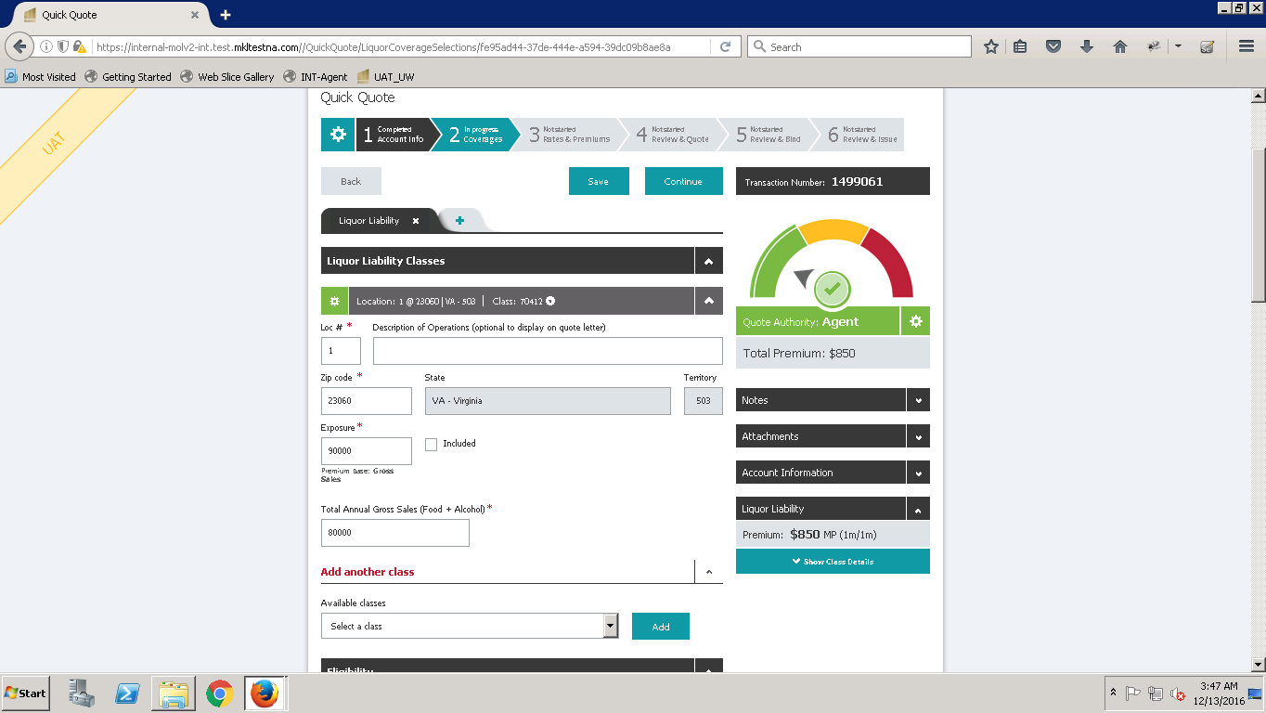

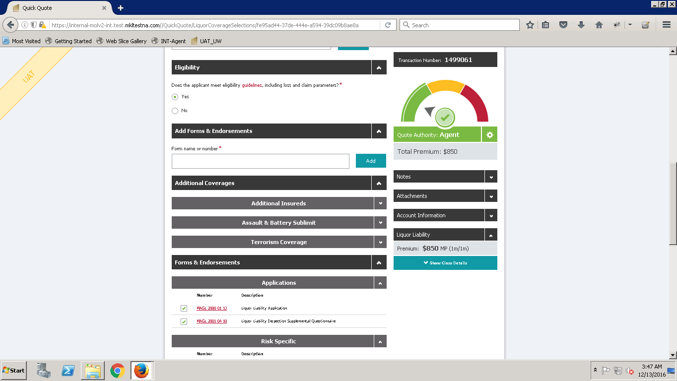

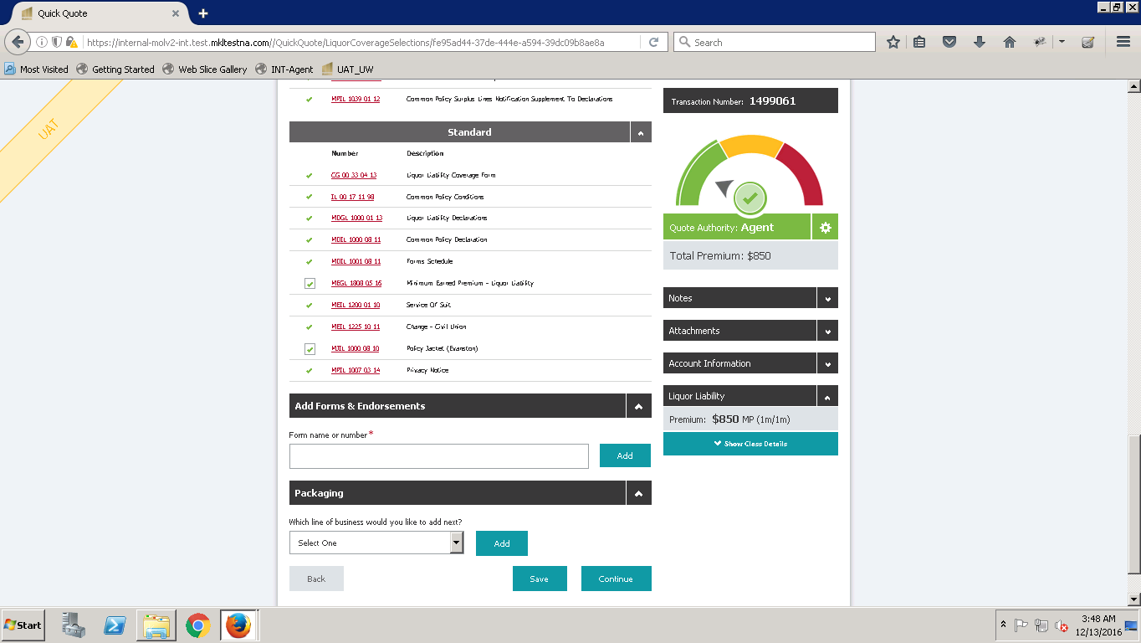

Dashboard on right side displays Notes, Attachments m Account Information, LOB Class and Rate details along with Quote Authority dial.

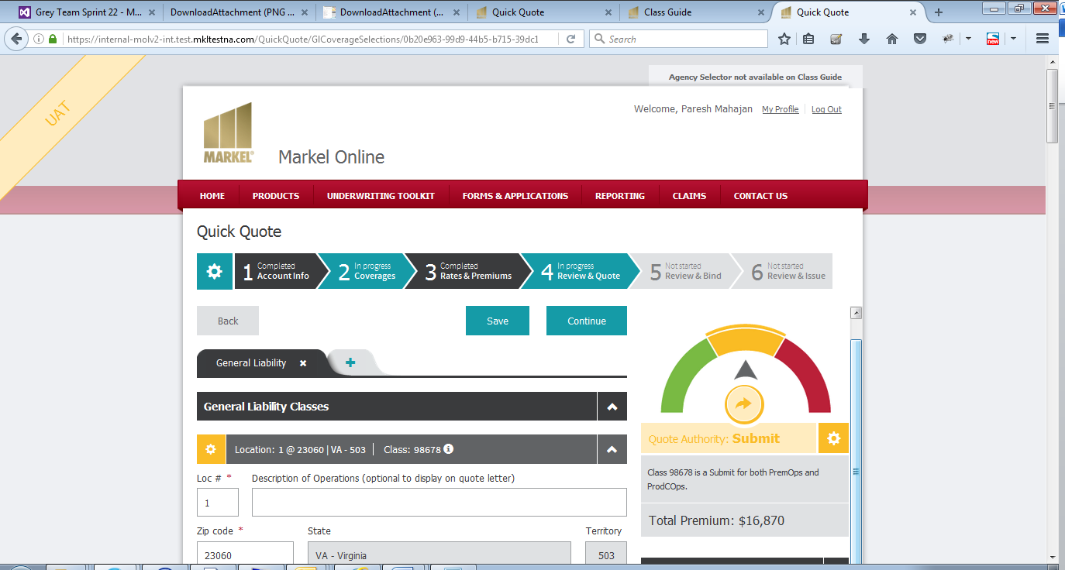

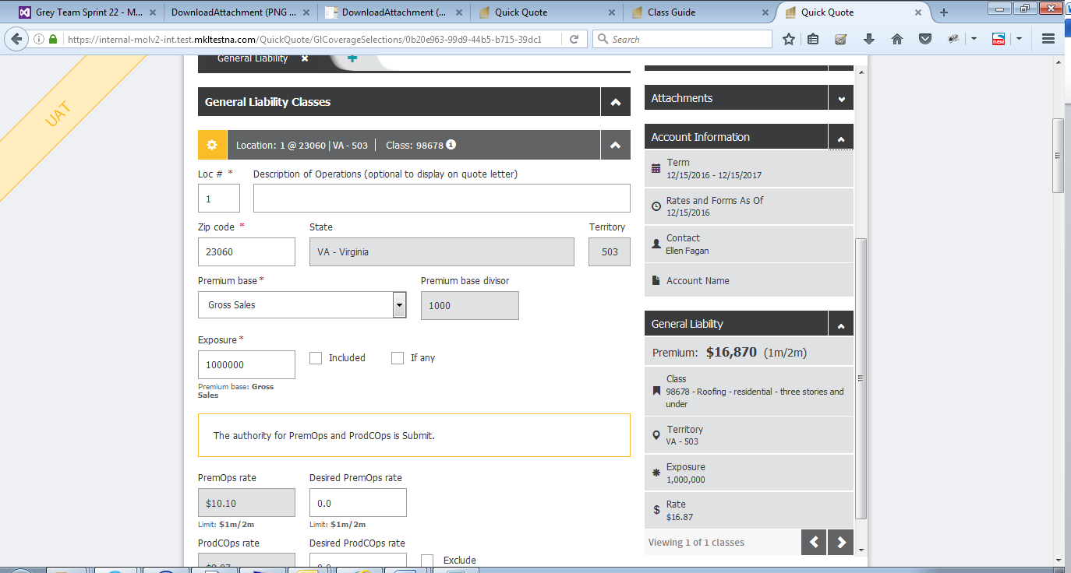

User can view Note and Guidelines on step 2 clicking the COG button or clicking ‘Notes & Guidelines‘ link.

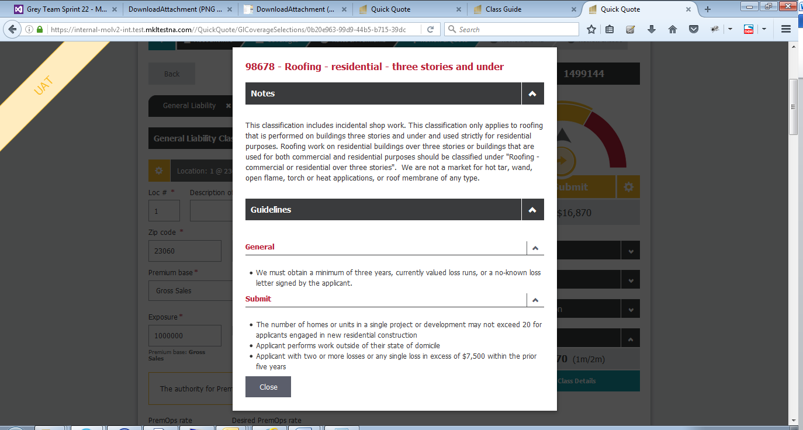

You can create the transaction for other Lines of Business as well in a single transaction to create package transaction.

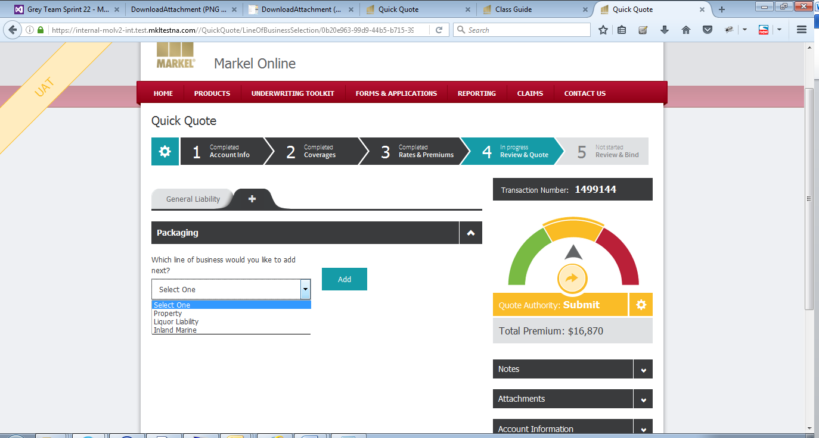

**Step 3(Rates & Premiums):-** Step-3 displays the system applied rates on the basis of coverage selection on step-2. It also displays the calculated premium on the policy based on the selection of coverages and additional coverages. Step-3 also allows user to customize the rates & Premiums applicable on the said policy.

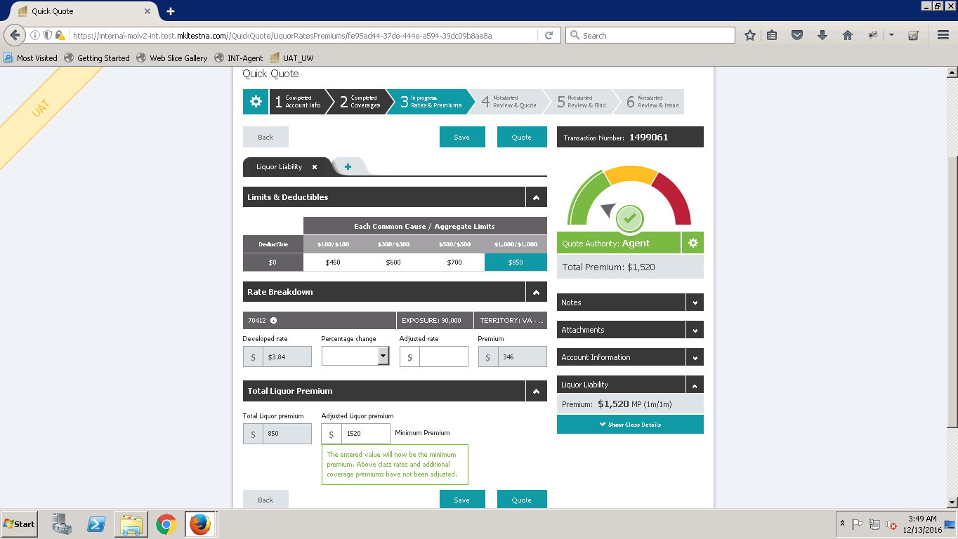

**Step 4(Review & Quote) :-** Step-4 typically displays the preview of Quote letter generated on the basis of the data entered by agent/underwriter on Step-1-2 & 3. On this step user can also add the additional information such as applicable charges, taxes etc. using “Additional Information” tab.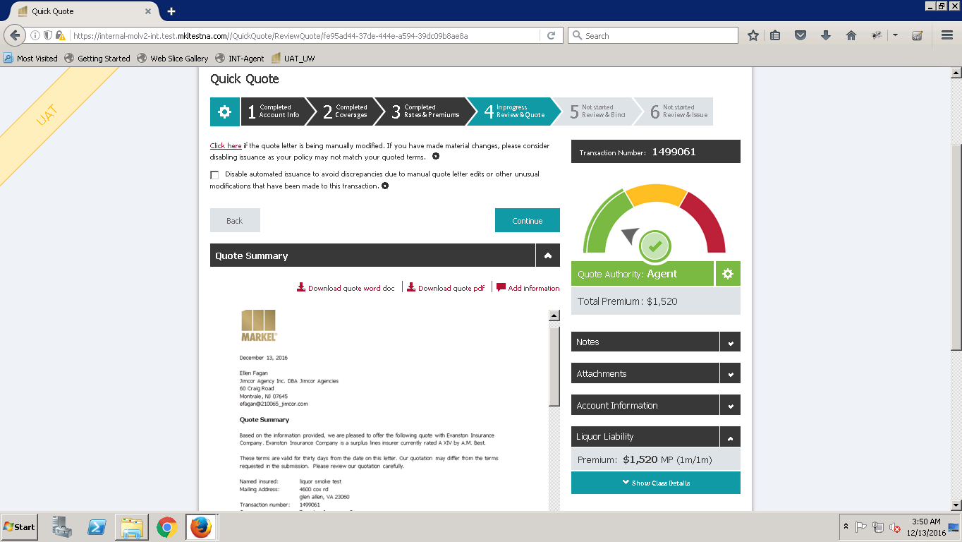

**Step 5(Review & Bind):-** Once the Quote is punched and customer is ready to enter in an agreement (Insurance contract) based on the agreed terms within the quote, the status of that Quote will become “Bind” that means both insurer and insured are agreed upon the terms, conditions, coverages & premiums

Mentioned in the initial quote document. 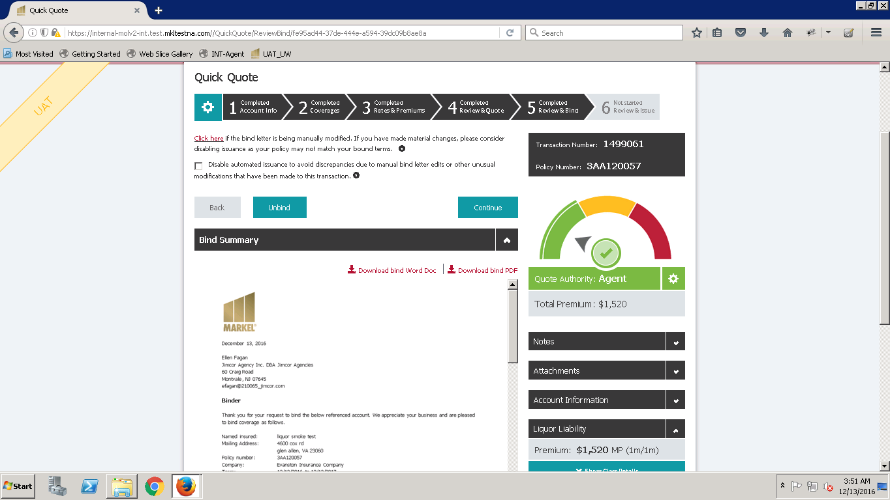

**Step 6(Review & Issue)**:- After ‘Bind’ step the Pocily will leagally come into existance as a unique policy code will get alloted and a final review will be done before issuing the policy to end customer. We also call this as a Pre-Issuance step as we review different type of mandatory/ optional forms on this step along with their mappings with Q&A. Once the review is done agent/Underwriter Issues the said Policy document by clicking on “Issue button”. Once it is issued system displays the option to download the full policy document which is finally presented to user. 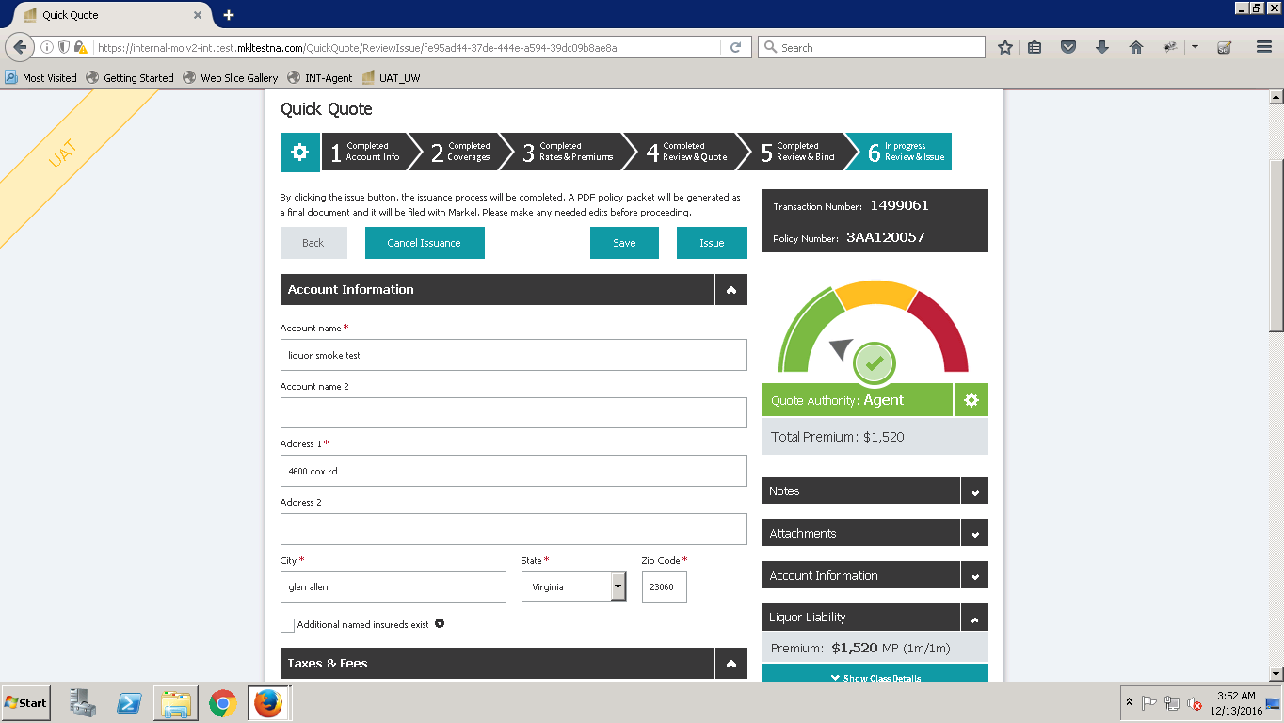

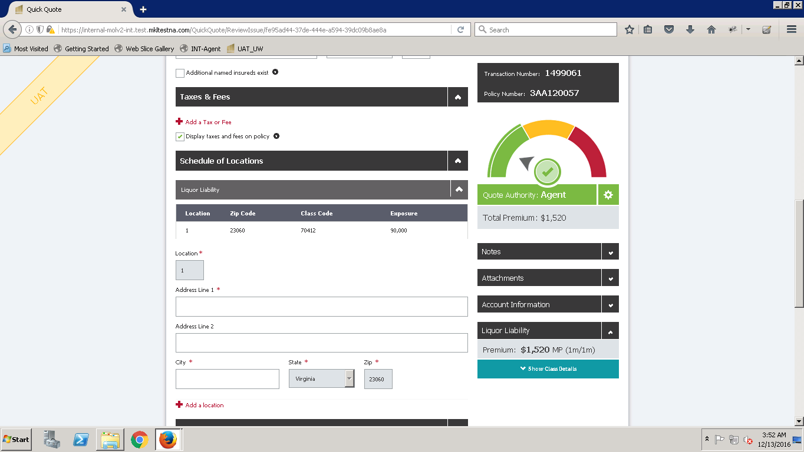

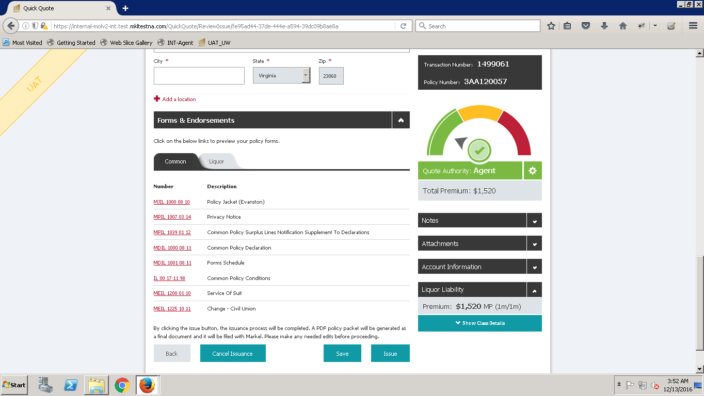

**Issue Policy :**

The Step 6 page appears in Read only mode after the policy is issued and the user can download the Policy PDF document.

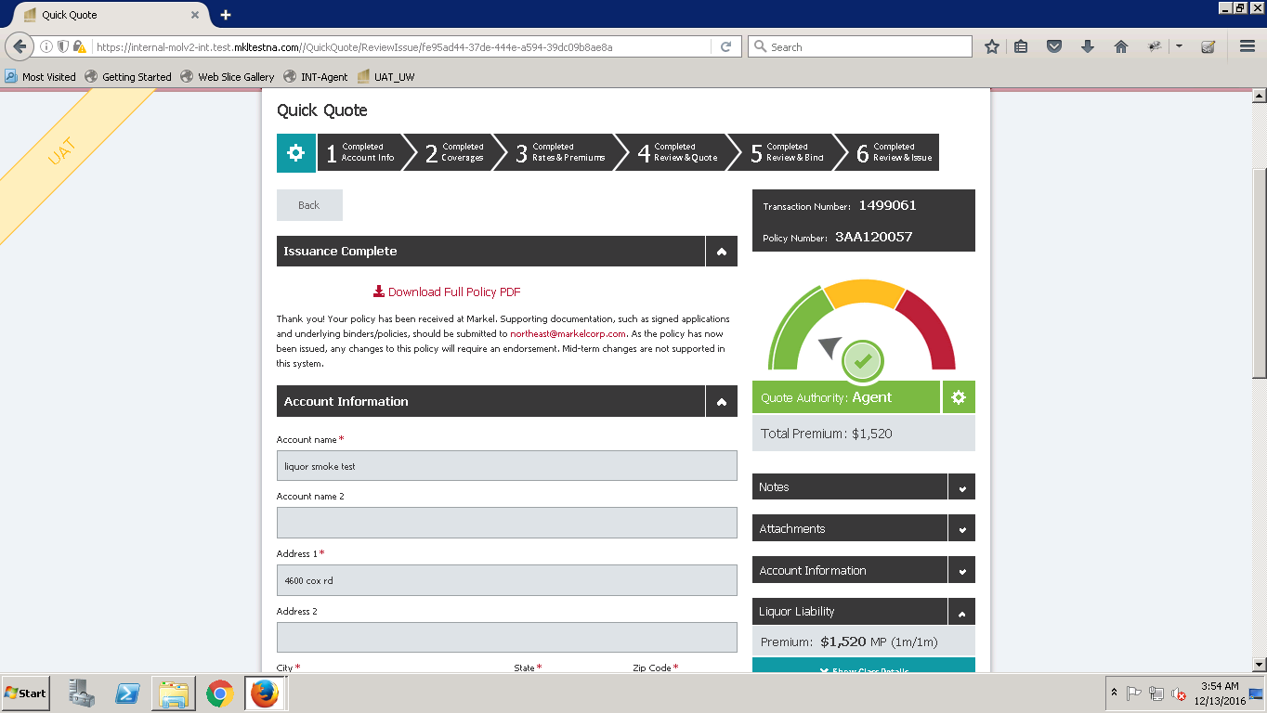

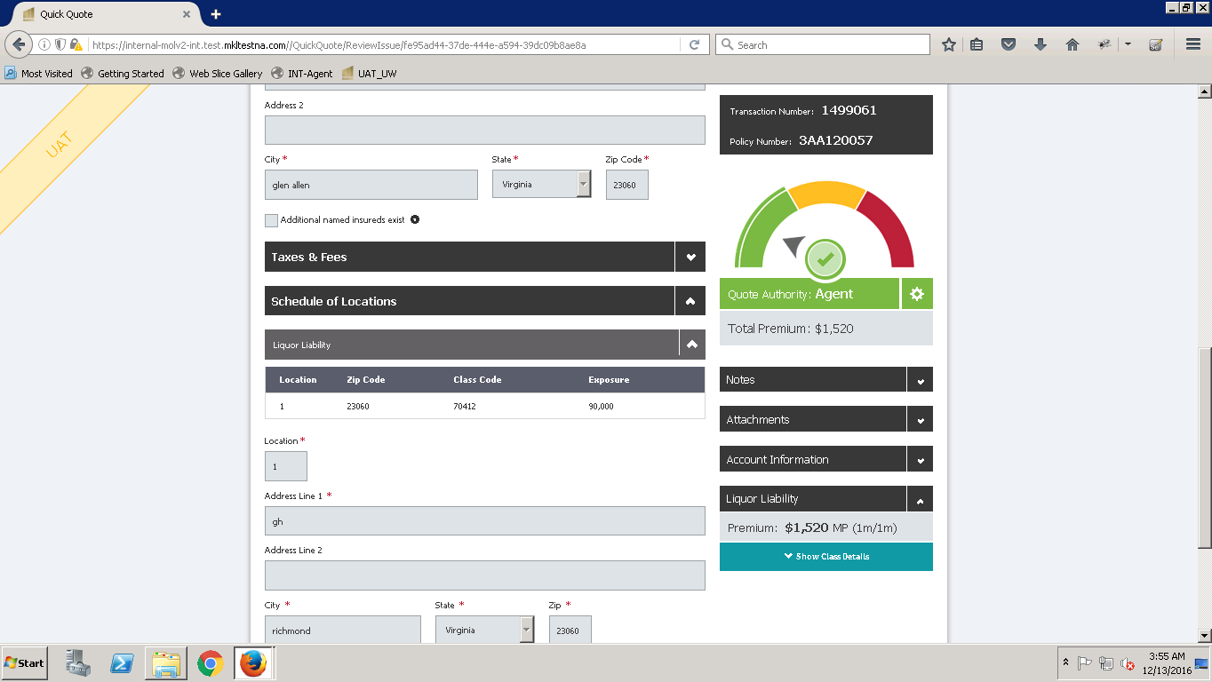

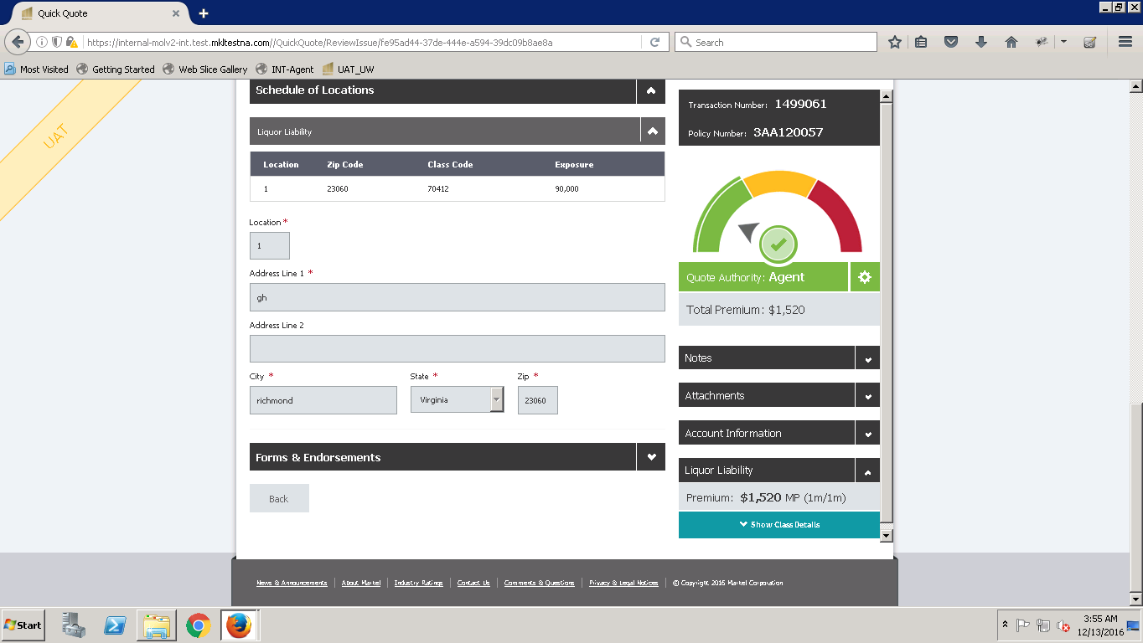

**Creating Transactions with different Lines of Business**

**Line of Business : Liquor Liability**

We will submit the Liquor Liability quote by following the steps as below :

Home Screen



Step 1(Account Info)…………………………………………………………………………….......................





Step 2(Coverages)……………………………………………………………………………………………...







Step 3(Rates & Premiums)…………………………………………………………………………………….



Step 4(Review & Quote)



Step 5(Review & Bind)



Step 6(Review & Issue)













**Similar transactions for SE and OCP Lines of Business :**



**Workflows**

There are four basic workflows associated with Quick Quote:

1.       Producer Quote Workflow (Agent Initiated) – producer creates quote

2.       Underwriter Quote Workflow (Underwriter Initiated) – underwriter creates quote

3.       Producer Quote Workflow with Referral – producer creates quote, refers to underwriter

4.       Underwriter Quote Workflow with Referral – underwriter creates quote, refers to producer

Each of these workflows can further be broken down into new business and renewal business.  New business is a request for a new insurance policy for a given line of business.  Renewal business is the continuation of an in-force policy.

Underwriters have permissions to view/edit any transaction.  Agents can only view/edit transactions that they created or that were created within their agency.

There are some features which user can utilize while creating the transactions :

New Business / New QQ (from Home Page)

Start a New Transaction

Delete this transaction

Copy for Renewal - not for OCP and SE LOB

Copy for Similar Risk

Release to Agent

**Admin Tool Integration**

Admin tool is an application which stores the information of different classes and forms as well for the user to access the information related to the class or forms. The user can utilize this information while creating quick quote in the application for different classes.

The user needs to have valid credentials to the Admin Tool.

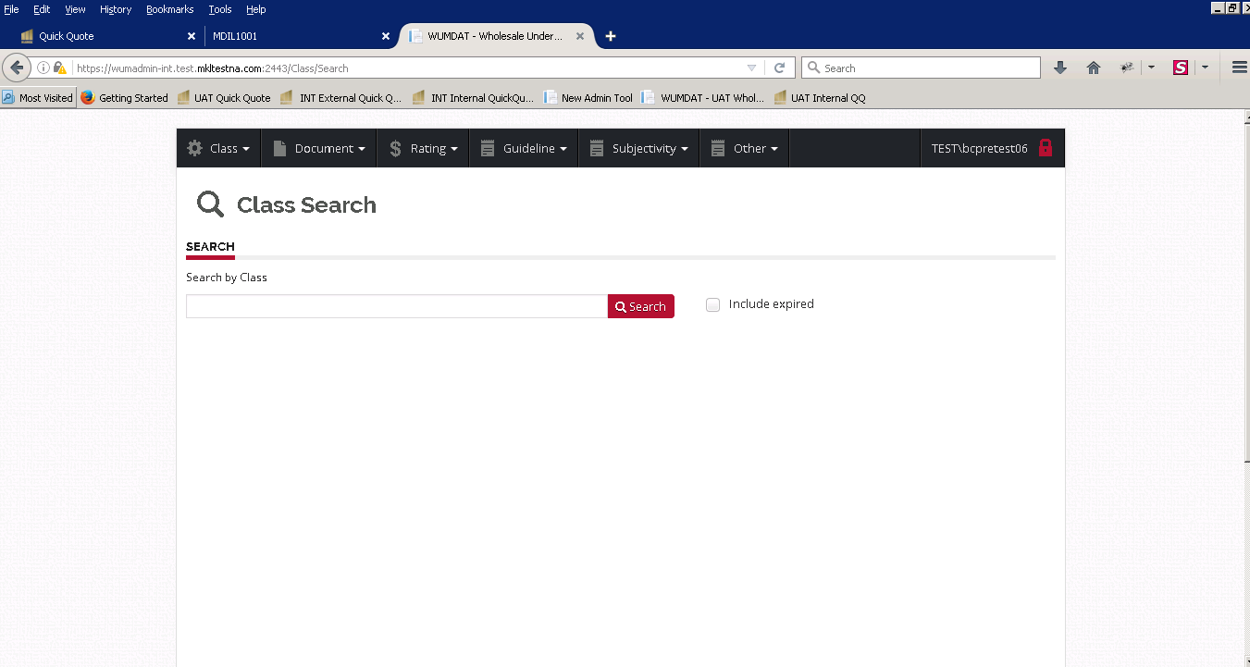

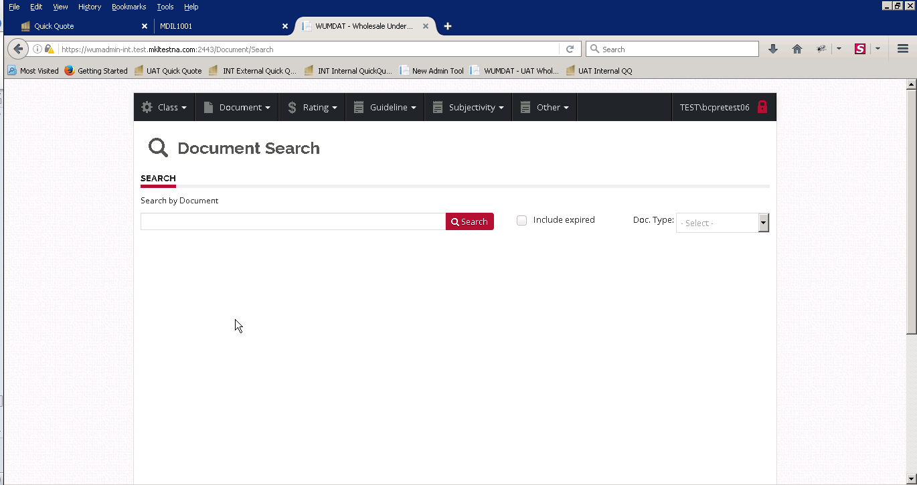

**Useful links**

Here are some useful links given below to access the MOL application and its details:

**Admin Tool:** <https://wumadmin-int.test.mkltestna.com:2443/>

**TFS:** <http://stwebdev30:8080/tfs>

**Integration Internal Environment access link :** <https://internal-molv2-int.test.mkltestna.com/quickquote>

**Integration External Environment access link :** <https://external-molv2-int.test.mkltestna.com>